

Aut/Win 2011-12 The Journal of Personalised Education Now Issue No.15
British Library International Standard Serial Number: ISSN 1756-803X

Why schooling is a major contributor to the crisis – and what can be done about it
Professor Ian Cunningham

Ian’s writing and work is so much in tune with the values and principles at CPE-PEN it’s always a delight when we can publish his thoughts. Here Ian links the wider societal context and ills to our schooling system. Using a wide range of references, exemplars from the Self Managed Learning Centre in Brighton, Ian develops a convincing argument of why we must tackle formal schooling and how we might go about that.

Introduction
In this essay I will use as my starting point the ‘Manifesto for Change’ elaborated by Robinson et al., 2009. Each of the nine points in this manifesto summarises exceedingly well the basis of the global crisis explored in their paper [SEE ENDNOTE].

Others have commented on a range of aspects of the socio-economic-ecological crisis affecting the planet - and all species on it. Here I will explore schooling and possible antidotes to the effects of current practices. Note that I am concerned about an alternative to current institutional schooling. Education is a broader concept, as is learning. Indeed one mistake official bodies make is to conflate learning and schooling as though they are synonyms for education.

All available research on learning shows that most of what we learn that is of value in our work, and lives in general, is outside school. The best summary of all the evidence suggests that, for instance, schooling in all its modes (and I will include here college, university and formal training courses) contributes at most 10-20% of what makes a good professional person effective. (See Burgoyne and Reynolds, 1997; Cunningham et al., 2004; Eraut, 1998; Eraut et al., 1998; McCall et al., 1988; Wenger, 1998.) Most of the useful learning that we gain comes from what tends to be dismissed (by officialdom) as informal learning, such as from peers, family, travel, reading, etc, etc. In our own research we have identified over 80 useful learning modes outside schooling. Some of these are summarised in Cunningham et al., 2004.
In what follows I will take just two examples of the nine ‘questionable assumptions’ challenged in the Manifesto for Change and make comments about their validity as applied to schooling. I will add some notes about alternatives that do work.

FIRST QUESTIONABLE ASSUMPTION
‘Separation of the individual from the social nexus and from nature, and the corresponding affirmation of individualism, individual success and self-interest (by contrast with ideals of community, co-operation and social responsibility)’ (Robinson, et al., p.3).

We become our selves through our relationship with others. We need to be in productive relationships with other human beings. Hence the notion of co-operation and community is central to how we develop. We know from the extensive researches of Wilkinson and Pickett, 2009; Marmot, 2004, and others that the greater the social distance within a society the greater are the problems of health, crime and psychosocial distress. An individualistic society where there are large differences in income and social status is bound to contribute to the social crises we face.

[CONTINUES OVERLEAF]

CONTENTS

pp.1-5: Why schooling is a major contributor to the crisis – and what can be done about it – Prof. Ian Cunningham
p.5: Truancy – will it help to replace the present compulsory system with a voluntary one? - Annie Clegg
pp.6-8: Educating Architects - Alan Clawley
pp.8-10:: Karl Marx and Global Poverty – A Re-awakening - Edith W. King

My argument is that schooling plays a major role in this and if we do not change the nature of current schooling practices there is no chance of addressing these social ills. As an example – in England seven-year-olds in school are assessed by what many educationalists recognise as a crude methodology. Parents eagerly discuss these ratings (SATs) and children quickly learn where they stand in the class. From then on children absorb the notion that some people are valued more than others and that if you have low SATs scores you are less likely to do well in school – and life.

A learning centre
We run a learning centre in Brighton for 11-16 year-olds who have chosen not to be in school. The reasons for this choice vary – some have been home educated prior to joining us; some have been bullied in school; some have found the classroom an impossible environment; some have been rejected by school. In the latter category is Tina. She came to us at 14 having had a range of difficult experiences in local schools. One of the things we do is to ask new students about themselves. In Tina’s case one thing we asked was about what she was good at. She replied “Nothing” – and she meant it. It was not false humility; she really believed that she was useless at everything. The messages that she had gained throughout her schooling were that she had no abilities of any value.

In working with her she has come to recognise that she will never succeed with high-level academic qualifications. However she makes a real contribution to our learning community. She is prepared to ask the difficult questions; she has a strong moral sense; she has learned to challenge others appropriately (she didn’t when she first came to us); she has developed her dancing and dramatic skills and become a good singer. And so on. She has developed the capability to work with others and to work independently – and these are qualities that employers say many young people coming out of school lack.

The role of the learning community has been crucial in supporting Tina’s development. Within the community each person is allowed to develop their own voice and to pursue their own learning. However they have to work with others to achieve their own learning. For instance resources in the learning centre have to be shared and students and staff together work out how the resources are used. There is no formal imposed content curriculum – the students negotiate with adults and their peers what they want to do during a typical week. As an example, students meet in small groups (a maximum of six students with one staff member) on a Monday morning to consider what they want to do in the coming week. Students are assisted to write their own timetables and to negotiate with adults and with peers on what they want to do.

Three of the girls play wind instruments and they have worked with Alison (a staff member) to form, with her, a wind quartet. Alison has arranged music for the quartet. All four need to agree when they will play together – and therefore agree with others in the community as to when they will have the music room. They also need to work together so that the quartet can create the lovely music that it produces.

This latter is a simple example of the need for students to be able to learn on their own (to be good on their own instruments) and to work together. Learning needs to balance the independent element and the interdependent element. The problem in schooling is that it encourages a different balance – that between dependence on others and counter-dependence (for example when a son says: “I am not influenced by my father – I just do the opposite of what he says”).

Schools tend to value the dependent learner – the one who is quiet in class, does what teacher tells them, doesn’t question the work that they are set, does all their homework on time – and so on. Some young people rebel (exhibit counter-dependent behaviour) – they mistake this for independence, when usually they are not actually doing things of value for themselves but merely getting into trouble.

Working with schools
We get asked to assist schools where they have students that they label as problems. The process we use both in schools and with young people out of school is Self Managed Learning. In this process the aim is to develop independence and inter-dependence – and in doing so help young people to be able to lead good lives. At the start we get the students to join a learning group of six students and one adult (as learning assistant). Once the group has agreed its rules for working and how it will operate we ask the students to answer five questions, namely:

- Where have I been – what has been my experience of life up to now?
- Where am I now – what kind of person am I, what do I care about, what interests me, what am I good at, etc?
- Where do I want to get to – what kind of life might I want to lead, what kind of work might I want to do, what goals for learning should I set myself now?
- How will I get to where I want to be – how will I learn what I want to learn?
- How will I know if I have arrived – how will I measure my progress and my development?

In answering that first question we often unearth major reasons why particular individuals are having difficulty in school. For instance in a group of 14-year-olds in a local school, Rochelle talked of her family experiences to date. Her parents split up when she was very young. Her mother had gained custody but her father had kidnapped the children at one point. The family feuding had culminated in the father smashing up the family home in the preceding week and beating up her sister. The school was getting annoyed with her because she was not doing her homework – but had no idea why there was a problem. For Rochelle doing her school work was not high on her agenda, given her home circumstances. And this story could be repeated a hundredfold in local schools – none of which seem organized to understand the real problems that many of their student face.

One reason that Rochelle was in the Self Managed Learning programme was that her year head had identified that Rochelle was mixing with what the year head labelled ‘a bad crowd’. Rochelle had been reasonably successful (by the school’s standards) in her first two years in the school but had been perceived to go down hill as a result of the changes in her friendship group. Interestingly the year head was aware enough of the influence of a peer group but seemed unable to act on the issue.

We know from our research that the peer group is usually the greatest influence on young people, especially teenagers. Adults such as teachers and parents are generally less of an influence, even though they may not recognize this. Schools promote an individualistic culture where, for instance, learners helping each other with their assessed work is punished (as cheating). However this can be undermined as students create their own subcultures inside school - and these generally dominate in terms of the behaviour of students.

In Rochelle’s case the learning group (of six students) was able to discuss the ways in which each person might want to develop (using the five questions indicated above). This led on to considering what might be difficulties for each person in achieving their life goals. In Rochelle’s case she realised that she wanted to work towards a professional career (her interests led towards the law). One piece of work the students did was for each to write out what the school would say about them now and what they would like the school to say about them when they left at 16.

Rochelle summed up her current situation very well – citing, for example, her difficult behaviour and the bad influence of her new friends. In writing what she hoped the school would say about her in two years time she suggested that she would still occasionally be difficult but that her behaviour had improved and that she had changed her friendship group. The others in her learning group agreed that what she was looking to change was the right thing to do and they pledged to assist her.

This is an example of how we look to balance independent and inter-dependent learning. Each young person needs to be assisted to develop ideas about what life they want to lead and how they will achieve this. However, the role of the group is crucial in being initially a test bed for these ideas and later both a support and a challenge for the person.

An example of this latter dimension is of the role of the group for 13-year-old John, who was in a learning group in another school. He had been having a difficult time and was in and out of exclusion from school. He committed to some significant life changes. One of these was to give up smoking. At the penultimate meeting of the group, Mike (another group member) started to sniff at John and alleged that he had been smoking. John denied this saying that he had just been with others who had been smoking. The group members decided to search John’s bag and his pockets to see if they could find any cigarettes. John agreed to this. Having failed to find any incriminating evidence they decided to accept John’s assertions.

This provides an example of how individuals may need support – and sometimes challenges to their behaviour. The rule we have is that you support the person while sometimes challenging what they do. The separation of who the person is from what they do is crucial. Because the group cared about John as a person they challenged suspected behavioural transgressions. In the process of challenging they demonstrated a significant level of support for him. And the overall role of the group demonstrated how it was important to develop a peer group that could act for good rather than ill.

Schooling
Schooling emphasises a range of structures such as classrooms, an imposed content curriculum, an imposed timetable and imposed rules. While some schools attempt to leaven the influence of such structures, the general process is one which creates a context for promoting individualism and self-interested behaviour. A counter to this has been the growth of democratic schools in many countries. There is increased interest from parents in the UK in such approaches, though officialdom tends to frown on democratic schools, as evidenced by the Government’s attempt to close Summerhill School in Suffolk.

The argument made by many supporters of democratic schools is that they better prepare young people for playing an active role in democratic society, since young people have to learn to make a democratic community work effectively. Another reason for support for democratic schools is exemplified by the need to counteract the second of the questionable assumptions from the ‘Manifesto for Change’, namely:

‘The separation of knowledge specialism in science, philosophy and humanities, leading to the fragmentation of knowledge (as opposed to a more interdisciplinary, co-operative and integrated approach)’ (Robinson et al., p. 3).

Addressing this questionable assumption
I remember in my first degree in chemistry asking my professor of physical chemistry – ‘what actually is an electron?’ (My question was prompted by the complex maths that we were asked to grapple with while never actually dealing with the oddities thrown up by quantum theory.) The professor pretty much told me to shut up as he indicated that my question was about philosophy (and therefore not legitimate in a chemistry lecture).

Later, doing a masters degree in occupational psychology we had a lecture within which was given a purely psychological explanation of some recent research. I suggested an alternative explanation for the same data and was pretty much told to shut up, as my explanation was sociological and therefore not legitimate. And I could go on with other examples of the separation problems in education. What is clear is that this fragmentation has serious consequences.

In schooling (including higher education) the separation of subjects means that learners are encouraged to think in fragmentary ways. This means that we may never solve ecological problems, as young people are discouraged from thinking systemically and holistically. Schooling’s hidden curriculum is that learning has to be compartmentalised if you are to succeed academically. This learning has more impact than the actual subject learning as it is hidden from the learner. For the learner it is part of the way things are and is not therefore available for challenge.

Even where teachers recognise the problem they seem to feel powerless to act to change things. One headteacher said to me that he would ideally love to get rid of all his science teachers because of the way science was being taught in his school. Yet he could not realistically do it – even though he was the head.

Modes of learning
Ideally learning needs to start with what I have called the ‘P MODE’. P stands for:

- PERSONS – we need to understand the person if we are to assist their learning. Each person is different and they have different needs.
- PATTERNS – each person will have patterns of behaviour and of thinking
- PROCESSES – each person has their own processes of working and living
- PROBLEMS – one way of thinking of learning is as a solution to a problem. For example if you can’t speak French and you need to then you have a problem and the solution is to learn French. Or if you need to write well to progress in life and work then the solution is to learn to write well. And so on.
Note that in the latter example, problems come before solutions. In our approach, the P MODE comes before the S MODE

The S MODE stands for:

- SOLUTIONS – to respond to the person and their problems there may be a need to look for solutions
- SUBJECTS – subject knowledge may help to meet the ‘P’ needs
- SKILLS – may be needed to progress
- SPECIALISATIONS – may contribute
as may
- SYSTEMS – such as IT systems.

Schooling too often starts with ‘S’ – young people have imposed on them Subject knowledge and Solutions to Problems that they have not yet formulated. Or the Solution distorts the way the Problem is addressed.

As a chemist, presented with the problem of mental health my training (schooling) would have oriented me to create a pill. Later, from working in the field of psychotherapy, my solution to the same problem would be to talk to the person. As far as I can gather chemists and psychotherapists don’t talk to each other yet they are dealing with the same problems. Schooling is predominantly in the
‘S Mode’ and distorts how we deal with the ‘P Mode’.

In our learning centre we try to avoid these issues. Tim came to us at age 12 with a passion for the TV series Dr Who. Through this interest he started to write his own scripts for a Dr Who series. This also prompted an interest in visual representation and he worked on a Mac to develop videos and comics. He decided that he needed to know more of the science underpinning Dr Who and this led into serious explorations in a range of sciences. For instance he wanted to explore the reason for the Doctor’s altruism and that led to the two of us discussing philosophical issues around altruism as well as ideas from Darwinism, genetics and evolutionary psychology.

Tim started in the P Mode with his Personal interest and this linked to his own Patterns of thinking. One of his Problems was to write better scripts hence needing better scientific knowledge. He also developed his ability in English through his writing. Given the time-travel dimension of Dr Who he developed his historical knowledge (again so that he could write better scripts). The learning mode here is ‘P’ before ‘S’.

Two errors can occur in learning.
Firstly starting with ‘S’ before ‘P’ leads to motivational problems, as many young people find it difficult to see the relevance of learning subject knowledge abstracted from their needs to live and work in society. Also ‘S’ mode thinking creates anti-ecological and anti-systemic thinking.

The other error is for learners to start in ‘P’ and stay there. They do need assistance to see how to use what is available in the ‘S’ mode, hence a role for adults. However our role is first to understand the person before assisting them to make the link to the ‘S’ mode, such as via subject knowledge and skills.

The curriculum
The standard educational (schooling) model for thinking about the curriculum has become a list of subjects and skills to learn (‘S’ Mode). However the choice of content is a purely subjective one. There is no objective basis for the school curriculum – the content is created by adults who live in a different world from young people.

When adults say that they were young once and can therefore understand the needs of young people, Margaret Mead (see Howard, 1984) famously responded something along the following lines: “Yes you were young once but you have not been young in the world that young people are young in. You were young in another world totally different from that of today.” To add to that it is clear that adults are not in a strong position to predict the world that young people will inhabit when they are adults.

The alternative to a content/subject curriculum is a process curriculum. Here the emphasis is on a systemic, holistic model where, through the process of learning, young people are prepared to deal with whatever the future may hold. Sometimes this emphasis is labelled ‘learning to learn’ though I would argue that it is bigger than this. We talk of Self Managed Learning (see Cunningham et al., 2000, and www.selfmanagedlearning.org ) as we emphasise the need for people to be self managing – though our model of self managing is one of balancing independent and inter-dependent thought and action.

An example of a real situation
The global financial crisis of 2008/9 is an interesting example of how the two questionable assumptions (individualism and knowledge fragmentation) have played out in a real situation. The best analysis of the roots of the crisis is in Tett, 2009. As a social anthropologist working as a journalist for the Financial Times she had access to the facts and an anthropological approach which exposed the lack of systemic thinking amongst the bankers and others who precipitated the crisis.
She commented:

‘…regulators, bankers, politicians, investors and journalists have all failed to employ truly holistic thought...a ‘silo’ mentality has come to rule inside banks…with shockingly little wider vision or oversight’ (p. 298-299).

The dimension of self-interest amongst the culprits (for example, excessive bonuses based on dubious criteria) has also been extensively explored. What is often missing from these analyses is the role of schooling in creating this mindset. If schooling rewards self-interested behaviour, and gives no credence to behaviour that has a social dimension, it is clear that this links to the way in which these and other organisational actors play out their roles.
The teams that created the toxic financial instruments not only did not connect to wider societal issues they did not connect to other operations within the banks. They betrayed the kind of arrogance exposed some time ago by Argyris (see, for example, Argyris, 1990). What he showed is that people who have been successful academically, such as via elite business schools, can develop a mindset where their mistakes are reframed as the mistakes of others. An example was his research on young management consultants who made inappropriate recommendations to clients and then blamed the clients when things went wrong.

Argyris’ demonstration of the need for double loop learning has largely fallen on deaf ears, as did Bateson’s earlier (1972) exposition of the value of second order learning. Schooling is committed to single loop/first order learning where the ability to step back and analyse one’s own learning, and the values and beliefs that underpin it, is discounted – and even discouraged.

People learn to think and work in silos. It is not an inborn feature of humans. Clark’s (2002) in-depth study provides ample evidence on this. Furthermore anthropologists studying hunter-gatherer bands comment on how such bands behave in a more ecological way (see, for example, Brody, 2001; Clastres, 1989; Gall, 2002; Gowdy, 1998; Lee and Daly, 2004). Hunter-gatherer people do not fragment the world as supposedly developed people do.

All humans lived in hunter-gatherer bands for over 90% of human history. It is therefore only relatively recently that we have moved away from this more holistic life-style. As evolutionary psychologists (for example Nicholson, 2000) argue, our brains and general make up are still what they describe as ‘stone age’. And in this mode we were able to keep our thinking connected to action. The abstract-thinking analysts in the banks disconnected their models from the reality of Mr and Mrs Smith and their sub-prime mortgage.

Indigenous peoples on islands in the way of the tsunami that hit South East Asia were able to survive because they could read the many signs from animal and bird behaviour that there was an on-coming disaster. They survived when others, such as tourists not used to holistic awareness, did not.

Conclusion
In this essay I have only taken the first two of the ‘questionable assumptions’ identified by Robinson et al., 2009. However other items on their list could also relate to issues in schooling. What I have wanted to demonstrate is that we have to address what goes on in formal institutional educational settings. If we fail to make changes in such settings then other worthy efforts may fail. Schooling has a significant impact on how people approach global crises and how they address them.

Endnote
The nine questionable assumptions have been spelled out by Robinson et al., 2009, as follows:
‘There is strong evidence that a fundamental paradigm has been a major contributor to the current impasse. Questionable assumptions underlying this paradigm are:
- The separation of the individual from the social nexus and from nature, and the corresponding affirmation of individualism, individual success and self-interest (by contrast with the ideals of community, co-operation and social responsibility).
- The separation of knowledge specialism in the sciences, philosophy and humanities, leading to the fragmentation of knowledge (as opposed to a more interdisciplinary, co-operative and integrated approach).
- The adversarial separation of reason from feeling and practical living, leading to the belief that science is a process devoid of feeling and intuition (which cries out for a new approach to knowledge which takes account of the full range of human experience).
- The prioritising of economic growth, material gain and quantitative profit as ultimate ends in themselves linked to a narrow model of laissez-faire capitalism (by contrast with an economics enlightened by a moral commitment to compassion and social justice).
- The deterministic and reductionist view of living beings as machines leading to the view that consciousness is an illusion (by contrast with the recognition of the distinctive nature of life and mind and their central place in our world).
- Nature and living beings as resources to be treated as objects for exploitation and consumption (rather than as a spiritual community of all beings).
- Science as the only path to reality, and empirical evidence as the sole criterion of truth (by contrast with a more embracing epistemology which recognises that there are many paths to truth).
- Matters of value, goodness, love, quality and beauty as merely subjective, and therefore subordinate to the physical sciences (rather than as embedded in the fabric of life and the cosmos).
- Science and scientific evidence as requiring or implying a world devoid of spiritual depth and spiritual knowledge (by contrast with a science which is seen once again as a part of the perennial search for wisdom).’ (pp 3-4)

Bibliography
Argyris, C. (1990) Overcoming Organizational Defences. Facilitating organizational learning, Allyn and Bacon, Boston.
Bateson, G. (1972) Steps to an ecology of mind, University of Chicago Press, Chicago.
Brody, H. (2001) The other side of Eden, Faber and Faber, London.
Burgoyne, J. and Reynolds, M. (eds.) (1997) Management Learning. Sage, London.
Clark, M. E. (2002) In search of human nature, Routledge, London.
Clastres, P. (1989) Society against the state, Zone Books, New York.
Cunningham, I., Bennett, B and Dawes, G. (eds.) (2000) Self Managed Learning in Action, Gower, Aldershot, Hants.
Cunningham, I., Dawes, G. and Bennett, B. (2004) Handbook of Work Based Learning, Gower, Aldershot, Hants.
Eraut, M. (1998) ‘Learning in the workplace’, Training Officer, Vol 34, No 6, July/August, pp172-4.
Eraut, M., Alderton, J., Cole, G. and Senker, P. (1998) Development of knowledge and skills in employment, Research Report No. 5, University of Sussex Institute of Education, Brighton.
Gall, S. (2002) The Bushmen of Southern Africa, Random House, London.
Gowdy, J. (ed.) (1998) Limited wants, unlimited means, Island, Washington DC.
Howard, J. (1984) Margaret Mead: A Life, Simon and Schuster, New York.
Lee, R. B. and Daly, R. (eds.) (2004) The Cambridge Encyclopaedia of Hunters and Gatherers, Cambridge University Press, Cambridge.
Marmot, M. (2004) Status syndrome, Bloomsbury, London.
McCall, M. W., Lombardo, M. M., and Morrison, A. M. (1988) The Lessons of Experience, Lexington Books, Lexington.
Nicholson, N. (2000) Managing the Human Animal, Texere, London.
Robinson, O., Clarke J., and Lorimer, D. (2009) ‘Crisis as Opportunity: Seizing the Moment for a New Renaissance’, Network Review, Summer, pp. 3-5.
Tett, G. (2009) Fool’s Gold, Little, Brown, London.
Wenger, E. (1998) Communities of Practice. Cambridge University Press, Cambridge.
Wilkinson, R. and Pickett, K. (2009) The Spirit Level, Allen Lane, London.

Ian Cunningham BSc, MA, PhD, FIoD, FRSA, Chartered FCIPD, FCMI is Visiting Professor in Organizational Capability at Middlesex University; chair of Strategic Developments International Ltd and chair of the Centre for Self Managed Learning. Previous positions have included Chief Executive of Roffey Park Institute; Senior Research Fellow in International Leadership at Ashridge Management College; Visiting Professor in Education Management in the Graduate School of Education, University of Utah; Visiting Fellow in Innovation in Education at the University of Sussex. He has published seven books and over one hundred articles and papers in areas such as education, learning, leadership, strategic management, organisational change and social change.

Ed Lines

A person who asks a question is a fool for five minutes; a person who doesn't is a fool forever.

Truancy – will it help to replace the present compulsory system with a voluntary one?
Dr Annie Clegg
Annie raises an important issue and that is the compulsory nature of our learning system. At CPE-PEN we have always maintained that learning and assessment should be invitational. We advocate the establishment of all-age, invitational, community learning centres and that schools should be recycled into them as soon as possible.

In considering the justice of legislation of a Compulsory Education Act two time factors are relevant: society at the time when the Act was first legislated and society after a century and a half has elapsed. I suggest that the objectives which appertained in 1876 cease to apply in the present era. Values in society move synchronously with changes which society undergoes over periods of time, and the time appears to be ripe for reappraisal and reform of a policy of education from compulsory attendance at a school to one of entitlement to education on a voluntary basis.

An invective on compulsory education need not represent an invective on the institution of schooling itself but will represent a precept for schooling of a voluntary nature. Permission to be in school is likely to produce respect for the institution itself as well as for the teachers, and a social spirit is more likely to flourish within kindred feelings of shared interests when subscribers to the system are subscribing by free will rather than by submission to sanction. Submitting freely to a process of education means joining humanity by the badge of literacy, and a person, as a social being, will normally join the ‘union’ unless discouraged by a subversive temperament.

Education is now closer to public acceptance in modern society and the compulsory element has nurtured a law which has acted as an unspecified ‘nanny’ long enough to be regarded as a dispensable item in our culture. A danger is, however, that the more firmly a practice becomes embedded into a culture the less reflection is likely to be made on whether it functions within a milieu of virtue and justice. There is no justice in using force to ensure formally obtained education just as there is a lack of virtue in ignoring its value. Education is something which the majority of people will nowadays find it possible to consent to without hardship (unlike the early days of the Act when family coffers suffered if helpful children were denied labour in the cottage industries) and is something which the majority of people will generally submit to without compulsion. Present-day society generally accepts that the provision of education is so important in our lives that the compulsory clause has outlived its utility. I ask whether it does harm to retain it as a law.

Harm may occur when coercion incites rebellion which devalues the internal goods of the practice of education. The act might have anomalously set the scene for rebellion against itself as evidenced in increasing incidences of truancy. Reasons for truancy are myriad and not restricted to hatred of learning. Truancy can be conceived as a means of staking a claim for freedom, and indications are that the compulsory method of ensuring education for the nation’s children is not working efficiently for all children. The compulsory law demands merely that there is attendance at school with no reference as to what success is achieved there. In other words, this kind of vigilance is merely serving as a safety-net for attendance only, and is not a safety-net for ensuring provision of well-educated future citizens. Rhetoric will often attach to a compulsive element in the form of procedures on others without their consent on the pretext of being in those others’ own interests.

When freedom has a high price will education reform in its favour prove to be worth it? It could be worth it if a reform to voluntary education could be trusted to retain what is valuable for the future practice of education; that whilst dispensing with oppressive elements desirable elements of the past are sacrificed to theoretical ideals.

Parental responsibility merits a degree of trust that in most cases children would be educated ‘at school or otherwise’, and children generally would merit a degree of trust that they could aspire towards achievement of excellence as many forefathers aspired to prior to the legislation of the Compulsory Education Act. The process of the reform to voluntary education may even be a return to values of the past which have been spurned or lost. Removal of the word ‘compulsory’ need not degenerate the basic elements which remain contained in a revised Education Law.

A move towards voluntary education could prove to be the catalyst which would be the redeemer not only for those for whom the institution was originally founded but the redeemer of the institution itself, especially as a solution to the problems associated with truancy.

Annie Clegg is a long time supporter of Education Now and subsequently CPE-PEN. In 2001, at the age of 74 Annie was awarded her Doctorate for a study in the philosophy of autonomous education, entitled ‘Children’s rights to greater freedom and self-determination’. Her thesis had its origins in the family experience of home-based education in the 1960s. Annie and husband Tony , who was a secondary school maths teacher and later teacher-trainer, elected to home-educate their family in Accrington – about 17 years before the founding of Education Otherwise.

Ed Lines

All men who have turned out worth anything have had the chief hand in their own education.
Sir Walter Scott

Educating Architects
Alan Clawley
Alan’s learning experiences with the Architectural Association in the 1960s look incredibly progressive and enlightened with their radical self-directed approaches.

Introduction
Formal education for architects is relatively recent. The Royal Institute of British Architects was only given its royal charter in 1837 and began ‘recognising’ schools of architecture in 1904.

The biggest and oldest school belongs to the Architectural Association or ‘AA’ which is a society of architects that was started in 1847 by a group of dissatisfied articled pupils whose primary aim was to establish a better system of architectural education. The AA is a professional and learned society and a centre of progressive architectural thought. The first ever full-time day school for architects was founded by the AA in 1901 in London. I was a full-time student at the AA in Bedford Square from 1963 to 1969.

The AA is the only architectural school in Britain which stands outside the national or local government education systems and university system. In theory this allows the AA to do just what it likes when and as it likes but the recommendation by the Oxford Conference on Architectural Education in 1958 that the best environment for architectural education was within a university, undoubtedly put pressure on the AA to conform. In 1964 the School was set to become the fourth college of the Imperial College of Science and Technology, South Kensington in parity with the Royal College of Science, the Royal School of Mines and the City and Guilds College. Fortunately, in my view, the merger never went ahead and an independent AA and School remained in Bedford Square where they have been since 1917.

The AA Philosophy
The essential feature of the relationship between the School and the AA is the invigorating contact of the School with a body of practising architects joined together in the AA specifically to ‘promote and afford facilities for the study of Architecture and to serve as a medium of friendly connection between the members.’ (AA Charter Article 1).

In the School Prospectus for 1998-9 the Chairman of the School, Mohsen Mostfavi, described the educational agenda of the AA as inexorably linked to questioning the status quo by focusing on a range of issues from the urban to the political, from the architectural to the emerging process of production, from landscape to alternative strategies for cross-disciplinary research, from technology and technique to ethics of sustainability and conservation, from the specific to the typicality of the everyday. He went on, ‘Partly planned, partly left to the fruitfulness of chance encounters, the diversity of the units is explicitly intended to lead to new discursive formulations and proposals which by definition violate disciplinary boundaries. In this sense, the AA has always been clear in its wish to be much more than a school that merely imparts knowledge: rather our main task remains to enquire and provide the best circumstances for dedicated individuals who are committed to producing the thinking and the work that will make a difference.’

My own experience
Although I had decided at 16 that I would study architecture I left Lancaster Royal Grammar School in 1962 without getting a place in one of the northern university schools of architecture. My grammar school had no experience of sending pupils to such places and gave me little support. My father asked Albert Walker, a Salvationist architect, if he could give me a job in his firm’s office in central Manchester. I became an office junior on £3 a week plus luncheon vouchers, but it gave me the chance to prove my worth to established professionals who advised me that the AA was the best place to go. The senior partner, David Gosling, wrote a glowing testimonial and I went down to London to sit the AA entrance examination in 1962. My parents were not well off so I was eligible to take another examination for a bursary of £100 a year to supplement the local authority’s discretionary grant for the fees and maintenance. There was some uncertainty because the fees were higher than those charged by universities.
Because of the open studio system at the AA every student had to buy a special reinforced lockable wooden box made in the AA’s own workshop. Inside was a set of recommended books, a scale rule and some drafting gadgets.

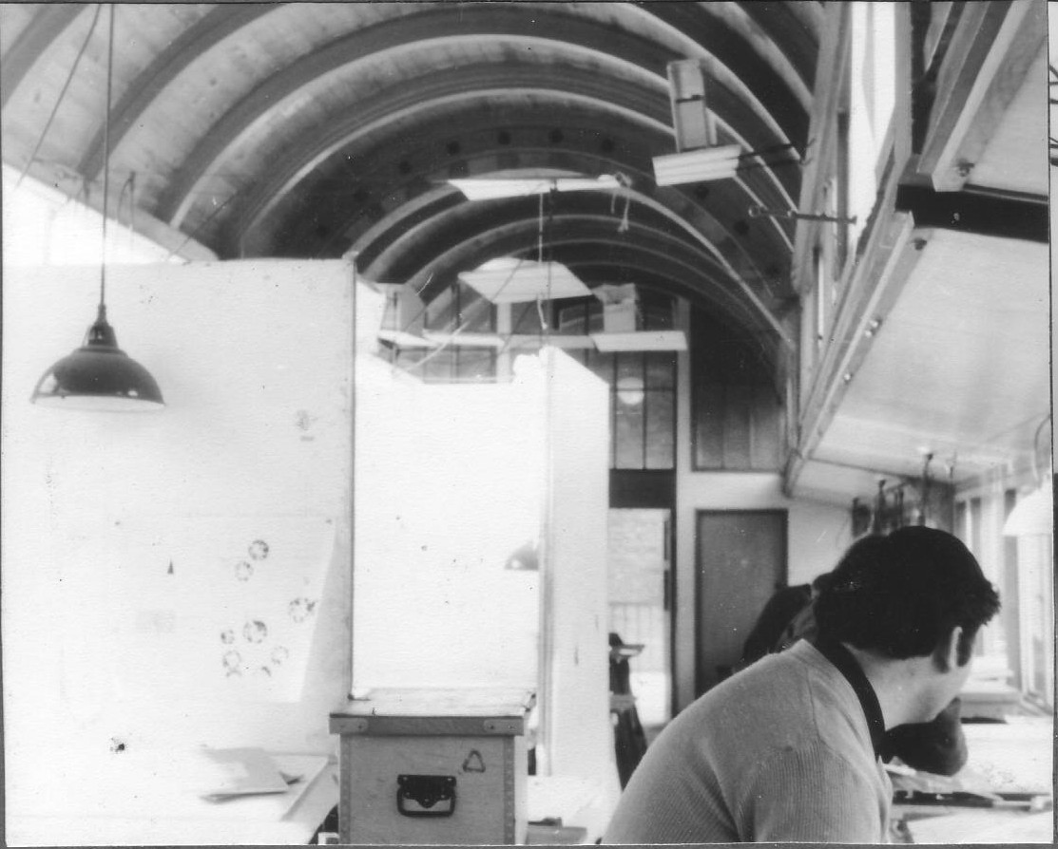
A studio at the AA School. Note the screens and the
‘architect’s box’

It was made clear from the first day that students weren’t told what to do. We had no one to blame but ourselves if we messed up. After the regimentation of a traditional boys’ grammar school this came as quite a shock. We were shown an empty studio and it was up to us to put up screens and trestle tables to make private spaces where we could put up a drawing board and keep our architect’s box. Groups were formed and theories of architecture and the progress or lack of progress of assignments dominated discussions whether in the studio, Chings Head (the basement café), on an arranged visit, or walking the streets of Central London.

In the first three years the School set the same assignments for all the students in the year. The yearly intake was 100 but we were divided into Units each with a Unit Master (still male dominated in the early sixties). We met our Unit Masters about once a fortnight to discuss progress, but the final presentation of the outcome was known as ‘The Crit’. Each student pinned their work on the wall in turn and explained it to the rest of the students in their unit or any other visitors who dropped by, but especially to the invited visiting architects or ‘Jury’. Afterwards the Unit master wrote a summary of the discussion and placed a copy in the student’s pigeon hole. Feedback was taken very seriously.

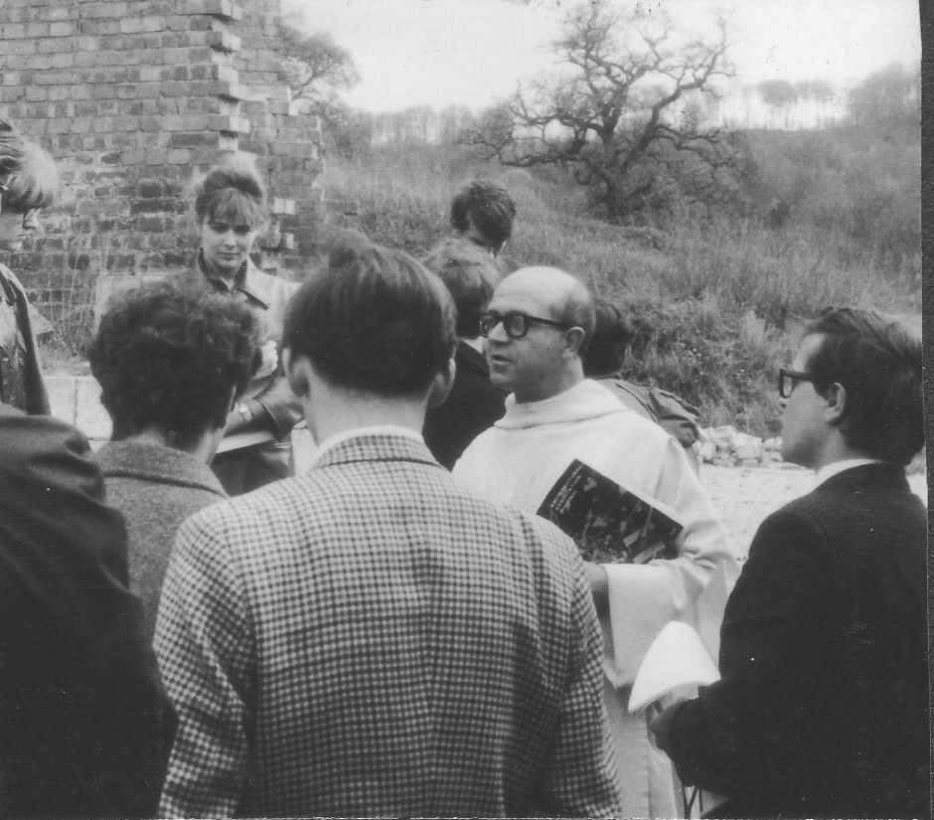
Second Year Assignment 1965: Benedictine monastery, Gloucestershire
During my second year (1964-5) the student body decided that the Principal, Bill Allen, was no longer fit for the job, and called successfully for his removal. Dr Koenigsburger was appointed but when I returned to the AA for the fourth year (1967-8) after a year in Runcorn new town, John Lloyd had been appointed. He brought in a radical system of self-managed learning. Students were now responsible for setting their own assignments and deciding what objectives they wanted to meet. It was a risky strategy. The danger was that students spent too long gathering information and too little time coming to any practical conclusion, but this was a lesson we had to learn by experience.
I remember that during my fourth year John Lloyd invited Michael Duane, the Head of Risinghill School, to visit the AA to talk about his educational philosophy. Working in groups was encouraged but was entirely optional. I did assignments with three other students.

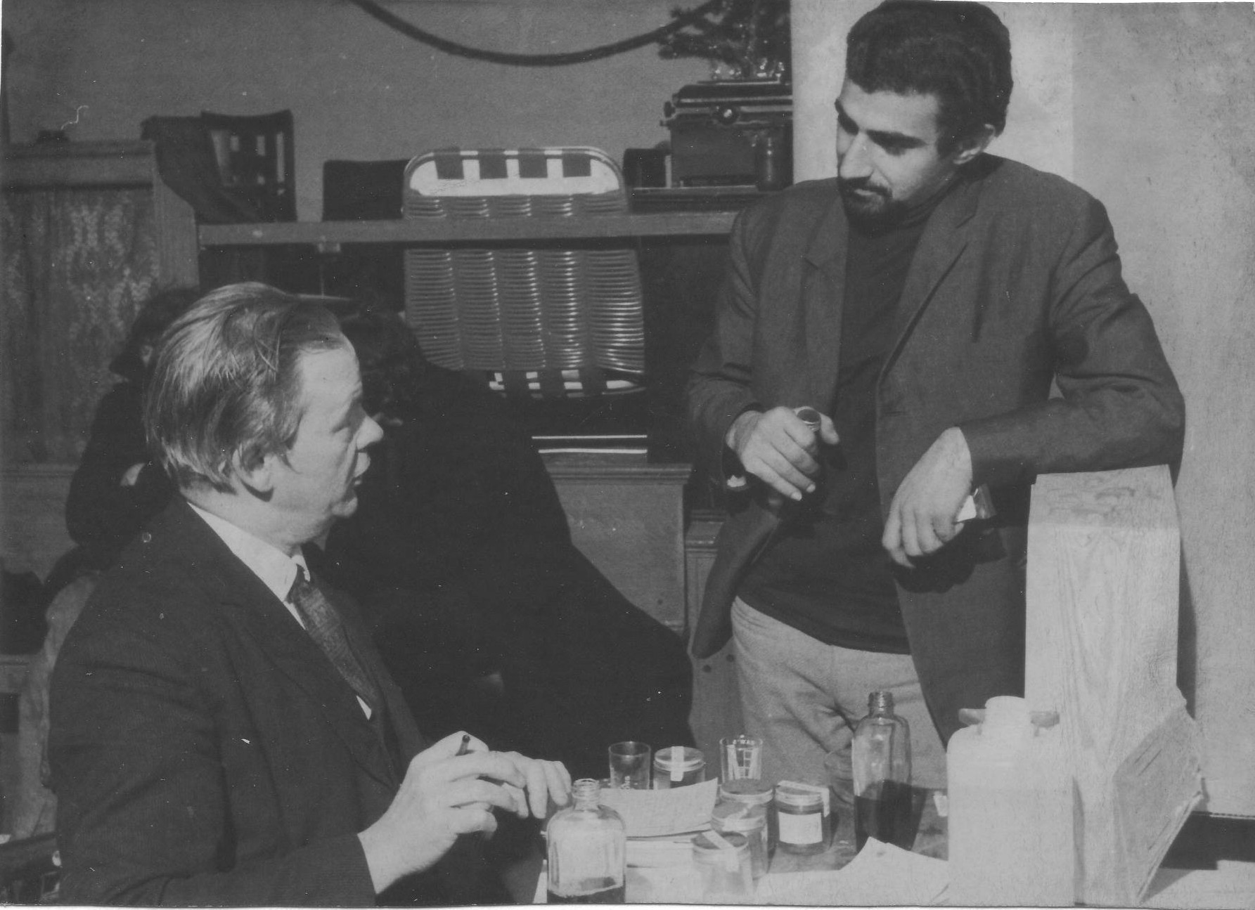
Self-selected fourth year project for the Chelsea Drug
Addiction Centre [with Alan Glover]

At the end of the five years there was no graduation ceremony. I remember our fifth year master Peter Cook (not he of Beyond the Fringe) telling us to think of the Diploma as a useful ticket that we could spend later if we wanted. I left without that piece of paper because I objected to having to supply a set of slides of my final thesis. Months later the AA relented and sent my Diploma by post in a cardboard tube.
Not all graduates of the AA became practising architects. Some, like well-known journalist Janet Street-Porter, valued the liberal education of the AA for itself. After leaving I worked in the Greater London Council for two dismal years designing housing estates in Expanded Towns in East Anglia. The Royal Institute of British Architects decided in its wisdom that with my limited experience of supervising builders on site I was not ready to belong to it. I concluded in turn that RIBA membership was not for me.

The educational philosophy that I was exposed to at the AA and an interest in architecture and built environment have stayed with me. The history thesis on the Edwardian architect Charles Harrison Townsend that I wrote in my final year at the AA convinced the Twentieth Century Society in 2009 that I could be trusted to write a book about Birmingham architect John Madin, which was published by the RIBA in March 2011.

The AA has constantly upheld its founders’ principal aim: to open up architectural practice and education to critical debate at all levels. Its ethos and teaching methods have been profoundly influential internationally, and today architects come from many areas of the world to study, work and teach at the AA. Amongst the AA’s alumni are Denys Lasdun, Lord Richard Rogers, Zaha Hadid and, surprisingly, Thomas Hardy.

Alan was first exposed to self-directed, personalised learning as a student at the AA School of Architecture in London when training as an architect. For some years he has earned a living as an independent consultant to the many and varied community organisations, voluntary groups and religious congregations that work in inner city Birmingham where he has lived since 1975. Alan has led the campaign of support for the modernist Birmingham Central Library, threatened by the Council with demolition. He is also a Green Party member and activist and a Trustee / Director of CPE-PEN.

Ed Lines

An ounce of practice is worth more than tons of preaching.

Mahatma Gandhi

Karl Marx and Global Poverty – A Re-awakening
Professor Edith W. King
Edith revisits Karl Marx, his works, impact and influence. She argues that Marxism deserves a re-awakening. In education the challenges of inherited wealth, power, global poverty and deprivation continue to confront educators and Marxism provides an important window on these issues.

Whether Karl Marx was the greatest social philosopher of the industrial age in purely intellectual terms is difficult to assess. What is less difficult to assess is his political effect. In terms of the numbers of people moved by his work, Marx must be considered as one of the greatest social critics and writers of his time. Reformist movements that shook the world and swept up populations numbering in the millions were undertaken in the name of Marx. Now in the 21st century it is useful to review his work with the thought in mind that, for better or worse, it has shaped human history. In this article I examine and put forth merely an overview of Karl Marx's trailblazing and piercing exhortations during his lifetime on the dire effects of poverty on children and women.

Recently a graduate student in an educational sociology class, who had just been introduced to some of Marx's writings, remarked to me: "I never wanted to learn anything about or even pay any attention to Marxism. The information from his writings on how poverty affects children gave me a whole new perspective on communism and socialism. I did not know that communism began as a humanitarian ideal. I grew up during the time of the Cold War with the USSR. I was always told about the evils of communism. It was important and eye opening to learn about the actual origins of Marxism."

Karl Marx in his Times
Born in 1818 in Germany Karl Marx came into the world in a period when the industrial power of Europe was truly beginning to manifest itself. His heritage derives from an intellectual base of rabbis and scholars. In 1843 he moved with his new wife, Jenny von Westphalen, to Paris where he was befriended by Friedrich Engels. Their Communist Manifesto, the platform of the Communist League, was published in 1848. The next year Marx moved to London. Here, in the legendary “Reading Room” of the British Museum, he spent many hours reading the horrendous reports of toiling in the growing numbers of industrial factories springing up across Britain, France and Germany. His studies led to the publication of his most famous work, Das Kapital, in 1867, that influenced the worker revolutions in Paris, and then across Europe. Karl Marx died in 1883 in London at age 65, two years after the deaths of his wife and only daughter. His massive memorial grave stands in the eastern section of Highgate Cemetery in suburban London. I visited Marx’ grave site with my friend Gillian Klein, publisher of Trentham Books, several years ago. I viewed Marx’s monumental tombstone with the famous words carved in the granite “Workers of All Lands - Unite.” I was touched by the peaceful green terrain that now surrounds the final resting place of this historic behemoth.

The Marxist Tradition
There is no denying the impact that the Marxist vision has had on the world. It produced in our time several major national bureaucracies surprisingly free of corruption (though corruption is found in all systems).
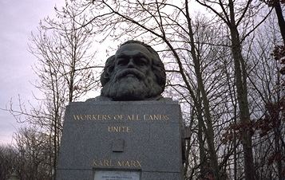

It produced a nearly puritanical morality in social and economic systems that, before being transformed by the Marxist vision, were corrupt and ineffective, not only China, but in other nations in the West, such as Cuba and Venezuela. We are witnessing today a historical epoch in which the forces opposed to the Marxist vision stand in somewhat the same position as those countries that stood opposed to the Protestant Reformation in the 16th century. Marxism is an essential part of the studies of anyone who is going into economics, sociology, anthropology, political science, or any of the other areas of humanistic interest. Marx offers one of the finer models of how to cope with a social or economic concern. He was thorough in his examination of the facts. He was broad in his historical perspectives. He developed a theme or theory in which the historical progression of a variety of events could be systematized. These are essential features of any powerful approach to social issues. The Marxist or materialist conception of history is fully described and detailed by Barton and Walker in A Sociology of Educating (Meighan and Harber, 2007).

There is something else in Marx’s writings that give them special vigour in this day and age of social objectivity. There is a sense of moral dedication and outrage. Marx documented that the 19th century road to progress was paved with decadence, corruption, and suffering. He not only described the social illnesses of his time; he also brought out the failures of the British educational system of his time. Few others in the 19th or 20th centuries have exerted so powerful an impact on the course of the world’s political, social, and economic future. In support of this advocacy consider the following excerpts from Das Kapital.

A classical example of over-work, of hard and inappropriate labour, and of its brutalizing effects on the workman from his childhood upwards, is afforded not only by coal-mining and miners generally, but also by tile and brick making. . . . Between May and September the work lasts from 5 in the morning till 8 in the evening, and where the drying is done in the open air, it often lasts from 4 in the morning till 9 in the evening. Work from 5 in the morning till 7 in the evening is considered “reduced” and “moderate.” Both boys and girls of 6 and even of 4 years of age are employed. They work for the same number of hours, often longer, than the adults. It is impossible for a child to pass through the purgatory of a tile-field without great moral degradation . . . the low language, which they are accustomed to hear from their tenderest years, the filthy, indecent, and shameless habits, amidst which, unknowing, and half wild, they grow up, make them in later-life lawless, abandoned, dissolute. (Marx, Das Kapital, pp.463 -464)

Marx noted that earlier craft or guild systems and the training of the apprentice could enhance the intellectual development of the child. By the 20th century, however, the rise of the machine had turned things around.

In the English letter-press printing trade . . . there existed formerly a system . . . of advancing the apprentices from easy to more and more difficult work. They went through a course of teaching till they were finished printers. To be able to read and write was for every one of them a requirement of their trade. All this was changed by the printing machine. It employs . . . boys mostly from 11 to 17 years of age whose sole business is either to spread the sheets of paper under the machine, or to take from it the printed sheets. They perform this weary task, in London especially, for 14, 15, and 16 hours at a stretch, during several days in the week, and frequently for 36 hours, with only 2 hours’ rest for meals and sleep. A great part of them cannot read, and they are, as a rule, utter savages and very extraordinary creatures. To qualify them for the work which they have to do, they require no intellectual training; there is little room in it for skill, and less for judgment. . . . As soon as they get too old for such child’s work, that is about 17 at the latest, they are discharged from the printing establishments. They become the recruits of crime. (Marx, pp.484 -485)

Marx also stated:
‘The children and young persons, therefore, in all such cases may justifiably claim from the legislature, as a natural right, that an exemption should be secured to them, from what destroys prematurely their physical strength, and lowers them in the scale of intellectual and moral beings.’ (Marx, p.489)

These passages make it quite obvious that Marx was concerned with the intellectual, as well as the physical well-being, not only of children who were oppressed by the factory system, but of adults as well. Das Kapital first appeared in 1867. Have poor children’s quality of living at home, in school, and in the community in many nations changed in the century and a half since the 1850s when Marx was writing Das Kapital? In every epoch events occur bringing the realization that millions of children and their families are living in dire poverty. In 2005 it was Hurricane Katrina striking the Gulf Coast of the United States that made all the world aware of the rampant poverty and racism existing in the American South. The horrendous earthquake in Haiti in 2010 again brought scenes of women and children ravaged by persistent traumas. Moreover, it appears that continually the affluent nations of the world are informed by the media through scenes of the poverty in rural India and across the African continent.

Applying Karl Marx in Our Teaching
The controversies and conflicts that now spread through the world because of Karl Marx are legion. No social scientist in contemporary times ever came so close to the heart of major social issues and expressed them in a way that divided people so forcefully into one camp or another. An issue arises out of the fact that Marx focused attention on the class structure as no other writer before him was able to do. Instead of idealizing the members of the upper classes, Marx described them as parasites who lived in luxury only because they stole from the working classes that which belonged to the working classes. Much upper-class wealth is inherited and therefore is unearned. If you believe people should be granted only what they earn, how do you deal with the problem of inheritance? This is no simple or light question. Democratic ideals sprang, in part, from the injustices that derived from the feudal system in which power was inherited. Money is power, and to inherit money and the power associated with it is to participate in a social and economic system that is closer to feudalism than to democracy. Yet, the denial of inheritance does not seem reasonable either. How do we deal with the problem of inherited wealth and power generally in educational settings? In the 21st century the legacy of Marxism deserves a re-awakening. The writings of Karl Marx convey for everyone a call for consciousness of those living in unremitting poverty and hopelessness.

References for the Major Works of Karl Marx
The major works of Karl Marx include the following:
The German Ideology, parts 1 and 3, with Friedrich Engels; introduction by R. Pascal .New York: International, 1939; originally written, 1845-1846.
The Poverty of Philosophy, with an introduction by Friedrich Engels. New York: Washington Square Press, 1964; originally written, 1848.
The Eighteenth Brumaire of Louis Bonaparte. New York: International, 1964; originally written, 1852.
A Contribution to the Critique of Political Economy, translated by N. I. Stone Chicago: Kerr, 1904; originally written, 1859.
Das Kapital: A Critique of Political Economy. New York: International, 1967; originally written, 1867-1879.
Marx’s books are available currently as Penguin Classics.
Also see: McLelland, D. Karl Marx: A Biography ; 3rd edition London: Macmillan, 1995.
Wheen, F. Karl Marx London: Fourth Estate, 1999.
References for this article
Allan, K. Explorations in Classical Sociological Theory. Thousands Oaks, CA: Pine Forge Press, 2005.
Cuzzort, R. P. Using Social Thought. Mt.View, CA: Mayfield Publishing Co. 1989.
Cuzzort, R. P. and Edith King, Social Thought Into the 21st Century. Ft. Worth, TX Harcourt, 2002.
King, E. W. Social Thought On Education (in press), 2011.
Meighan, R. and Harber, C. A Sociology of Educating, 5th edition. UK, Continuum: 2007.

Edith W. King became an educational sociologist over 45 years ago with her doctorate from Wayne State University in Detroit, Michigan. For the past four decades as Professor of Educational Sociology and Chairperson of the Worldmindedness Institute in Denver, Colorado, has served as a dedicated teacher and mentor to countless doctoral and masters students and alumni, many of whom have gone on to serve as faculty in universities and colleges throughout the US and the world, including in Taiwan, Japan, Saudi Arabia, and Kuwait. Most recently she taught courses in Sociology of Education; Ethnicity, Class and Gender in Education; Education for a Multiethnic Population; Qualitative Research Methods; and International Education and Human Rights.
In years past she organized travel seminars for graduate students, teachers and administrators to study education in international settings in Britain, Singapore, Mainland China, and Canada. Many know and identify her with the term "Worldmindedness" as not only is this the closing in all of her correspondence, it identified her unique seminars, federally-funded institutes and course offerings during the 1960s through the 1990s. The term "Worldmindedness" reflects her philosophy and teaching of global understanding, education for peace-building, and women's rights.
During her career spanning four decades she has authored numerous articles, papers, reports on topics and issues covering textbooks for the teaching of sociology of education, the impact of ethnic identity, Islamophobia, female genital mutilation (FGM), terrorism and teaching, illegal immigrant children. She is the author of over 15 textbooks including: Looking Into the Lives of Children...A Worldwide View (1999); Twentieth Century Social Thought (1995) with R. P. Cuzzort; Meeting the Challenges of Teaching in an Era of Terrorism, 2nd edition (2009); Social Thought Into the 21st Century 6th edition (2002), dedicated to R. P. Cuzzort (posthumously).

Ed Lines

All people found guilty of being born are sentenced to 12 years of hard labour without bail.

Soul Riser

PERSONALISED EDUCATION NOW

The vision of Personalised Education Now built upon
a funded Personalised Educational Landscape.

* A focus on the uniqueness of individuals, of their learning experiences and of their many and varied learning styles.

* Support of education in human scale settings, including home-based education, community learning centres, small schools, mini-schools, and schools-within-schools, flexischooling and flexi-colleges, networks of groups or individuals, both physical and virtual.

* Recognition that learners themselves have the ability to make both rational and intuitive choices about their education.

* The integration of learning, life and community.

* Advocacy of co-operative and democratic organisation of places of learning.

* Belief in the need to share national resources fairly, so that everyone has a real choice in education.

* Acceptance of Einstein's view that imagination is more important than knowledge in our modern and constantly changing world.

* A belief in subsidiarity… learning, acting and taking responsibility to the level of which you are capable.

* Adoption of the Universal Declaration of Human Rights, UN Convention on the Rights of the Child, European Convention for the Protection of Human Rights and Fundamental Freedoms.

PERSONALISED EDUCATION NOW

Maintains that people learn best:

* when they are self-motivated and are equipped with learning to learn tools.

* when they feel comfortable in their surroundings, free from coercion and fear.

* when educators and learners, value, trust, respect and listen to each other.

* when they can invite support / challenge and co-create their learning pathways from those educators and others they trust.

* when education is seen as an active life-long process.

What is meant by ‘Personalised Education’?

Personalised education as promoted by Personalised Education Now is derived from the philosophy of autonomous education. This centres on learner-managed learning, invitational learning institutions, the catalogue/natural versions of curriculum, invited rather than uninvited teaching, and assessment at the learner’s request. Its slogan is, ‘I did it my way – though often in co-operation with others’ and it operates within a general democratically-based learning landscape that has the slogan, ‘alternatives for everybody, all the time’.

Within the context of the UK ‘schooled society’ there are already some key institutions that work to the autonomous philosophy within a democratic value system. A prime example is the public library. Others are nursery centres, some schools and colleges, museums, community arts projects, and home-based education networks. They work to the principle of, ‘anybody, any age; any time, any place; any pathway, any pace’.

Such institutions are learner-friendly, non-ageist, convivial not coercive, and capable of operating as community learning centres which can provide courses, classes, workshops and experiences as requested by local learners. These are part of a rich and successful, but undervalued personalised learning heritage, from which we draw strength, and which we celebrate.

Personalised Education is legitimated by the latest understanding about the brain, and how we develop as learners and human

beings throughout our lives. It operates within a framework of
principles and values resulting in learners whose outcomes are expressed in their character, personality, in the quality of life they lead, in the development and sustainability of our communities and planet, and in peaceful coexistence and conflict resolution. Learner success is therefore measured in terms of good physical and mental health, in peaceful existence, freedom from crime, usefulness of their contributions and work, and levels of active
citizenship. In reality, these are more significant than the limitations and delusions of over-emphasis on assessment scores and paper accreditations.


Recycle Schools Now into invitational, all-age community learning centres operating year round.

Personalised Education Now seeks to promote educational ‘alternatives for everybody, all of the time’ through a diverse, funded Personalised Educational Landscape. This would meet the learning needs, lifestyles and life choices made by individuals, families and communities. State funding would be secured through vouchers or personal learning accounts. We encourage education based on learner-managed learning, using a flexible catalogue curriculum, located in a variety of settings, and operating within a framework of democratic values and practices. An educator becomes, pre-dominantly, ‘the guide on the side’ rather than ’the sage on the stage’.

The Centre for Personalised Education Trust (CPE)

Personalised Education Now (PEN) is the trading name for The Centre for Personalised Education Trust (CPE), a charitable company, limited by guarantee (Charity number: 1057442). It emerged from Education Now in 1996 as The Centre for Personalised Education Trust (CPE). In 2004, after 17 years’ pioneering work, Education Now transferred its resources and membership to PEN.

What can you do?

This is a message for everyone. Enter a dialogue with as many people as you can. Share the journal (hard and digital copies) with others. Engage them in the issues and encourage membership of PEN.

There are kindred spirits in all sorts of surprising places and of course there are those who just need a little more convincing. Often people partly understand but cannot conceptualise solutions or how we move forward. The arguments are not about blame as we need to engage the present system, not alienate it. One of our roles is to explain and show how current learning systems are and how things could be different. Within a developing personalised educational landscape solutions will evolve according to localised possibilities, including ways of learning that we have not yet imagined. It’s all too easy to take the moral high ground and believe we have all the answers because patently the enterprise is challenging and far from easy. But even as it stands we can share the rich history and current practice of learning in all sorts of settings. These signpost a better, brighter learning future.

Publicise and forward our web and blog links, circulate our PEN leaflet (from the general office). Bring the strength of PEN to succour those currently engaged in personalised education, and provide vision to those who are not.

To find out more, visit our websites:
Main site: http://www.personalisededucationnow.org.uk
Blog: http://blog.personalisededucationnow.org.uk/
Educational Heretics Press: http://edheretics.gn.apc.org/
Roland Meighan: http://www.rolandmeighan.co.uk/

Contact Personalised Education Now
Enquiries should be made via Janet Meighan, Secretary, at the address in the next column or on Tel: 0115 925 7261

Personalised Education Now Trustees
Peter Humphreys – Chair
Janet Meighan – Secretary
Alan Clawley - Treasurer
Roland Meighan – Membership Secretary / treasurer
Christopher Shute
Phillip Toogood
Hazel Clawley
Josh Gifford

Journal Publication Team
Peter Humphreys – Managing Editor
Email: personalisededucationnow@blueyonder.co.uk
Christopher Shute – Copy Editor
Hazel Clawley – Copy Editing / Proofing
Roland and Janet Meighan
Contact via the General Office (see next column)

Copy Contributions

Journal:
Contributions for consideration for publication in the Journal are welcomed. Authors should contact any of the Journal Publication Team to discuss before submission.

PEN operates an ‘Open Source’ policy: PEN resources and copy can be reproduced and circulated but we do request notification and acknowledgement.

Blog – Ezine:
Contributions via http://www.personalisededucationnow.org.uk/ContactUsSubPage.php
personalisededucationnow@blueyonder.co.uk

Newsletter:
Contributions for the Newsletter are also welcomed. Contact Janet Meighan.

Membership of Personalised Education Now

Personalised Education Now welcomes members, both individuals and groups, who support and promote its vision. Its membership includes educators in learning centres, home educating settings, schools, colleges and universities. Members include interested individuals and families, teachers, head teachers, advisers, inspectors and academics. PEN has extensive national and international links. Above all the issues of personalised education and learning are issues with relevance to every man, woman and child because they lie at the heart of what kind of society we wish to live in.

Newsletters

January 2012
July / August 2012

Journals

Issue 16 – Spring - Summer 2012

Learning Exchanges / Conferences

Further information - blog / newsletters.

Join Personalised Education Now

Membership Includes:

Minimum of 2 PEN Journals a year and specials
2 PEN Newsletters a year
Learning Exchanges (free)
Discounted publications from Educational Heretics Press
Access to and support of a diverse network of learners and educators.

Your membership supports:

Ongoing research and publications
development of the PEN website, blog, learning exchanges and conferences and other resources

---------------------------------------------------

Yes, I would like to join Personalised Education Now

Subscription:
£25 (£12 unwaged)

Send cheque made payable to the Centre for Personalised Education together with the details below:

Name individual / Group / Organisation:

Address:

Postcode

Tel:

Email:

The Centre for Personalised Education Trust
Personalised Education Now
General Office
Janet Meighan, Secretary
113 Arundel Drive
Bramcote, Nottingham
Nottinghamshire, NG9 3FQ

Contact Janet for details of payment by Standing Order and of Gift Aid contributions.

PRINTED BY: SAFFRON DESIGN & PRINT
Chapel Works, Aldridge Road, Streetly, Sutton Coldfield,
West Midlands, B74 2DU. http://www.saffrondesign.co.uk/

